Correlation Coefficient(r)

***Code***

proc corr; var co2emissions incomeperperson lifeexpectancy;run;

***Output***

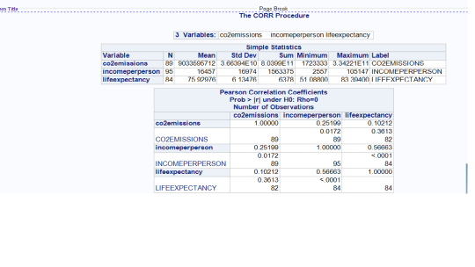

***Interpretation***

C02emmisions and lifexpectancy  have very weak positive correlation

r=0.102,r2=0.011 it explains only 1% variability of lifexpectancy

incomeperperson and lifexpectancy  have a moderate positive correlation

r=0.567,r2=0.321 it explains 32% variability of lifeexpectancy